Company Name: The music variety
Slogan: Your favorite music all in one place!
Logo:
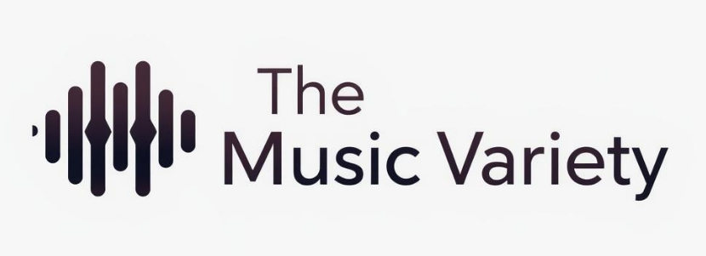
Home page: Brief introduction and description
About us page: The story and how we founded the company
Product page: Albums, instruments, etc.
Contact us page: Map, contact number, email, etc.

